**Marketing and CRM Assignment**

Laxman Babu K

PGDABI01202116285

**Index**

|  |  |  |
| --- | --- | --- |
| **S.No** | **Topic** | **Page Number** |
| 1 | Overview | 03 |
| 2 | Conduct Porter’s Five Forces Analysis on the industry that the local organization of your choice works in. Comment on profitability opinion about the industry based on the analysis. | 04 |
| 3 | Comment on the most important P of the marketing mix for this organization and support your opinion with arguments | 07 |
| 4 | Compare STP of this organization with another organization in the same category/segment but which works on a global (larger) scale. | 09 |
| 5 | Compare the relationship strategies of the two companies. Especially points out the difference in the relationship strategies adopted by these companies. Also, comment on why there exist differences between the two | 11 |
| 6 | Comment on the PLC stage of each of the two organizations and how these organizations are managing their marketing efforts with respect to the PLC stage they are in. | 12 |
| 7 | References | 13 |

**Overview of the Industry:**

Over-the-top (OTT) services are related to movies and television (TV) shows that are delivered on to digital users by eliminating the need for cable or satellite TV subscription. The platforms hosting these services are called OTT platforms, they are typically a subset of Cloud-based services which allows the users to either view or download the content and view them later via the internet to connected devices like laptop, tablet, smartphone, and TV.

India is currently one among the emerging markets for OTT platforms. A report from PWC quotes that “India will be the tenth-largest market for OTT in terms of revenue in 2022, with mobile internet subscribers set to double from 406 mn in 2017 to 805 mn in 2022. The OTT video market is being propelled by consumer content demand, lower internet prices and portability preferences. Increased focus on localized content is the key to the Indian OTT market.”

**Q1. Conduct Porter’s Five Forces Analysis on the industry that the local organization of your choice works in. Comment on profitability opinion about the industry based on the analysis.**

**Porter’s Five Forces Analysis of the OTT industry.**

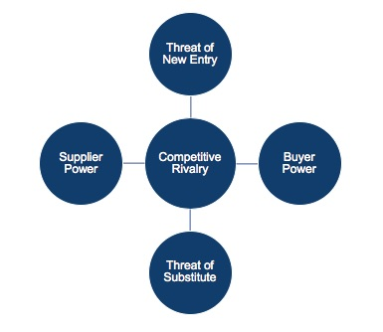

***1. Threat of New Entrants:***

OTT is one of the newest forms of digitalizing the viewing experience for the user. The industry faces no new threats at the moment as it emphasizes on delivering content directly to the user anywhere and anytime. The Industry is a subset of the Cloud-based web services and stands way above the existing platforms for entertainment like Cable TV, Theaters and Video on demand (through set-top boxes).

Whereas for entry to a new entrant who doesn't have their own video content the threat is significantly high as it involves extremely high investments needed in either producing new content or acquiring content from production houses. In case of entrants from the existing media houses or production companies, the risk is fairly low as they have content ready at their disposal along with a fan base of the existing content which can be directly used in the platform. E.g. 1. Walt Disney, who is a popular production house with huge collections of content partnering with Hotstar an existing OTT platform in India forming Disney Hotstar. e.g. 2. Geetha Arts who is a prominent production house in Telugu has launched its own streaming app called AHA.

***2. Power of suppliers:***

The rise of OTT is not only an additional platform for the content producers to showcase the talent but is also empowering them by bypassing the Movie distribution system. Traditionally, the OTT platforms like Amazon Prime Video are required to sign an exclusivity deal with the movie distributors i.e. they are not allowed to place the content on the platform for at least 30 days from the release of the movie in theatres. But the trend is now shifting more towards OTT as the movies are now being released exclusively on the platform due to COVID and non-availability of theatres. E.g. Gunjan Saxena (Hindi, Netflix), The Irishman (English, Netflix), Nishabdh (Multilingual, Amazon Prime video), etc.

The OTT platforms are also empowering the content creators by recovering their production costs and also gaining profits by releasing them in exclusively in the OTT which gives them the confidence of profit irrespective of the result of the movie. The platform also provides high visibility to the content across the languages and countries gaining them higher appreciation and fame e.g. Tumbad (Multilingual, Amazon Prime video).

***3. Power of Buyers:***

The Bargaining power of buyers will continue to increase with the increasing number of streaming services. The industry is not very price-sensitive. As all the streaming services in India are priced at very similar rates. Netflix prices between INR 199-1000/Month, Amazon Prime video at INR 129/Month, Disney Hotstar at INR 999/Year. The prices for Netflix vary with the number of users and the streaming quality.

Viewers are not bound to contracts with the streaming partners and are free to subscribe to any partner every month with the option to cancel at any time, hence adding power into the hands of the viewer. The power of buyers cannot be underestimated here, with viewers now having the choice to watch whatever they want if they cannot find something they desire on one service partner they can simply look on to a different competitor allowing the viewers to switch the partners if the content is moving to a different partner e.g. Marvel content moving from Netflix to Disney Hotstar. Therefore the power of buyers will always be high because of how easy it is for viewers to join and cancel subscriptions.

***4. Threat of Substitute Products:***

The traditional entertainment methods pose a low or no risk to the OTT industry currently with the decrease in the number of Theater releases to decrease in the volumes of tradition broadcast especially among the young adults. Yet there are instances where the viewers enjoy the theatrical experience more than the content and prefer the Theaters.

There exists a moderate threat from sources of entertainment other online streaming like leisure activities (especially after the COVID situation). Streaming partners might need to update the content to maintain the customer base.

***5. Competitive Rivalry:***

There exists a competitive rivalry among the traditional broadcasting services and the OTT platforms as both of them are coming with content to grab the viewers attention. Similarly, the competition between the Theaters and the OTT platforms are subjected to viewing experience vs content as the viewer who is more inclined to enjoy the viewing experience would prefer the theatre.

***Profitability Opinion:***

Overall the profitability of the OTT would lie in if the service provider has a content production studio under it e.g.: Disney, Netflix. Alternatively, the company can also be profitable if the organization is already well known in the country and is trying to expand into the OTT industry with a backing of a good content production company e.g. Amazon Prime Video and JIO cinemas.

**Q2. Comment on the most important P of the marketing mix for this organization and support your opinion with arguments**

Amazon Prime Video India has been launched in 2016 and has been luring Indian consumers to use its streaming platform. Coming as a service of the renowned Amazon.in which has revolutionized the e-commerce industry with its prime 2-day delivery concept and it will leave no stone unturned in. Being one of the largest companies, it has an enormous amount of capital to spare, threatening its competitors to survive in the pricing wars in future.

**7P analysis for Amazon Prime Video:**

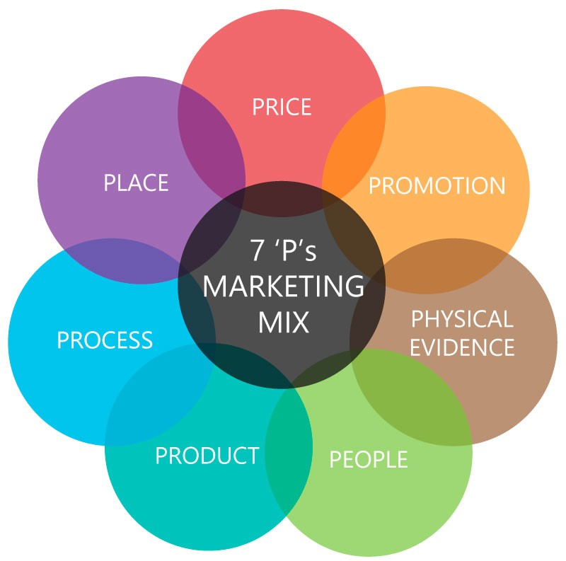

***1. Product:***

APV has been focusing more on providing regional content like ‘Mirzapur’, ’Inside Edge’ along with the international content which has an edge over the competitors like Netflix and Hotstar. APV has a more inclusive and public favorite content on Amazon ranging from drama to comedy. Many of its shows are on top trending list such as ‘Marvelous Mrs. Mazel’, ‘Homecoming’, ‘Bosch’, ‘Mirzapur’, ‘Comicstan’, etc. APV also actively partners with the regional and south Indian production houses and acquiring rights to the content more aggressively than the other competitors.

***2. Price:***

APV comes along with the Amazon Prime membership at a price of 129/Month which bundles 2-day delivery, free shipping, APV, Amazon Music, Prime reading through Kindle, etc. It’s the lowest among its contemporaries and smartly converts its e-commerce customers to APV. Since it is marked at the lowest price point, which can also be termed as penetration pricing, it is easily the best strategy to win more number of customers faster.

***3. Place:***

APV does not need a physical space to cater to their customers. APV can be accessed using the mobile app or the website. APV along with the other service providers have gained attention from customers making it easier for them to watch their shows on the go.

***4. Promotion:***

APV has the most unique way of promoting its customers by offering them an entire ecosystem of Prime benefits for the price of one membership. APV has also taken demonstrated its strategies by partnering with a few of the biggest network providers by providing free memberships to its premium users. Amazon also boasts that the user can enjoy Prime benefits at the lowest price when compared to others.

***5. People:***

APV comes from Amazon which has a vision of being “the world’s most customer-centric company”. Amazon is known for the commitment to its customers and providing products at the lowest possible price making it more trustworthy to customers who search for value for money.

***6. Process:***

The process of obtaining an APV license is different when compared to its competitors as it is provided with a Bundle along with other Prime benefits. APV can be accessed through a mobile app or the website

***7. Physical evidence:***

Physical evidence is the tangible aspects of service as this is a digital service rather than a physical once.

***Most important ‘P’:***

With reference to the above analysis Promotion, Price and Product are the most important P’s for Amazon Prime video are more focused in delivering more benefits to the customer by offering bundled benefits like 2-day delivery, Amazon music, Prime reading, free delivery, exclusive Prime deals and are successfully converting their e-commerce customers to Prime video and vice versa. Amazon Prime Video is also successful in reaching the non-urban areas by creating regional content and also acquiring regional movie rights aggressively thus having a higher value for money than its competitors.

**Q3.Compare STP of this organization with another organization in the same category/segment but which works on a global (larger) scale.**

In this scenario, we will be working on Amazon Prime Video (APV) and Netflix.

**Segmenting:**

***Netflix:*** Due to growing demand and easy use Netflix has showcased its segmentation on the idea of the subsequent factors.

* Demographics (Age, Gender, income)
* Psychographics (personality, Value, opinion)
* Viewership(number of screens)

They offer a differentiated product to those corresponding segments supported their individual preferences. Consequently, the targeting and positioning methods used for these segments vary greatly.

***APV:*** APV has segmented in India based on the following factors.

* Demographics (Region, Language)
* Psychographics (personality, Value)
* Value Proposition (price, benefits)
* Customer-Centric

**Targeting**:

***Netflix:*** The Netflix targeting approaches vary for each segment. Millennials are targeted by showcasing ‘no advertisements’ aspect, adults aged between 35-50 years are promised quality videos streamed to perfection, available at reasonable prices, on up to 4 screens.

***APV:*** APV has targeted a range of demographics within India thus creating localized content and have a huge collection of content with every major language. APV has also targeted the millennials by showcasing ‘No advertisement’ and has targeted the Urban and non-urban viewers by localized content.

**Positioning:**

***Netflix:*** Netflix has positioned itself with the tagline “Netflix and chill” within the minds of users and future users as being most:

* Comfortable
* Reasonable
* Compatible
* Personalization-friendly
* High quality
* User friendly
* Up-to-date

Portal for viewing content on different screens.

***APV:*** APV has positioned itself by the tagline “India ka Naya prime time” (India’s new primetime) thus positioning itself as the alternative for the existing TV viewership and movie-going communities. APV has also targeted on the value for money proposition by showcasing the multiple advantages of Prime membership in their advertisements thus attracting a large viewership. In a particular interview Jeff Bezos stated that “I didn’t want to repeat the mistake of Steve Jobs — pricing the iPhone in a way that was so fantastically profitable that the smartphone market became a magnet for competition” Thus clarifying its stay on the pricing.

APV has also partnered with the telecom giants in India like Airtel and Vodafone Idea to offer Prime membership at offer prices thus penetrating into the customer base of the telecom partners.

**Q4.Compare the relationship strategies of the two companies. Especially points out the difference in the relationship strategies adopted by these companies. Also, comment on why there exist differences between the two**

During its launch in India, Netflix was looking to capture viewers who were interested in international content thus limiting their reach into the Indian market with their famous tagline “Netflix and chill”. The Netflix library during that period was also very less when compared to the international library. Currently, Netflix is ready to invest nearly 300 million USD on regional content to lure non-English speaking users resulting in the shows like “Sacred Games”, etc. Netflix has also come up with customized pricing strategy for India thus resulting in the packages starting as low as INR 199 / month.

On the other hand, Amazon which states it’s the most customer-centric organization in the world in its mission takes Customer relationships very seriously. Amazon had the knowledge of the Indian market from its e-commerce site along with a huge database of customer, thus giving them a competitive advantage during their launch, APV and positioned itself as “India ka Naya prime time”(India’s new primetime ) and focused mostly on the regional content including different languages of the country. APV has also focused itself as a customer-centric company by offering multiple benefits to the value-conscious market and placing itself in the highest value for money category. APV has also partnered with multiple telecom giants in the country and offered its users prime memberships on an offer price thus penetrating the customer base of the telecom companies.

The differences between the two strategies are primarily because Netflix wanted to bring International content to Indian market where APV created and acquired Indian content to provide the viewer's new experience in their hands.

**Q5.Comment on the PLC stage of each of the two organizations and how these organizations are managing their marketing efforts with respect to the PLC stage they are in.**

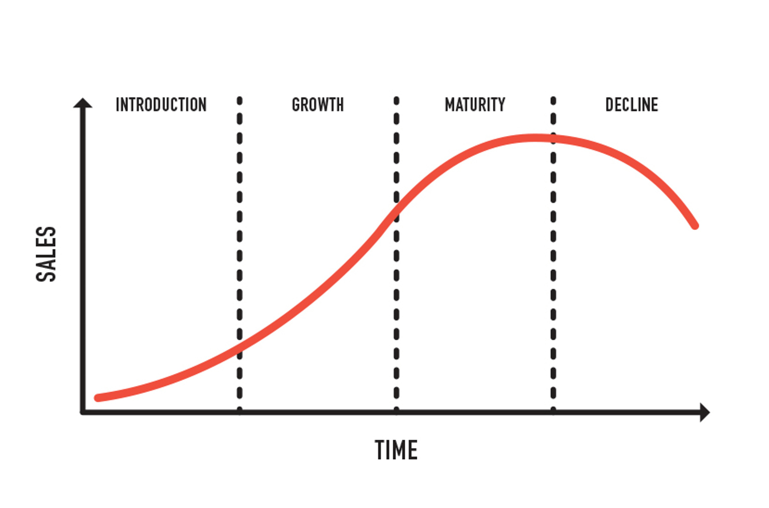

**Netflix:** Netflix started in 1997 as a video distribution company which aims at distributing DVDs and blue rays on a rental basis, this business model is currently in the decline phase and may phase out very soon owing to the changes in the DVD and Blu-ray market transitioning into video streaming services.

Netflix has shifted its business model from renting DVDs and Blu-ray to streaming services as a strategy to come out of the decline phase and start a new cycle. The company has also rebranded itself as “Netflix and chill” and also content anytime. Netflix has now entered the maturity phase of the business and is now focusing more towards producing its own content called the Netflix originals to lure the viewers.

**APV:** Amazon Prime video has entered with the Indian OTT market with a lot of experience from its e-commerce data base and is also positioned itself as “India ka Naya Primetime”. APV has also entered the maturity phase of the business and is focusing more on the regional original content and luring the customers by offering Prime memberships at an offer price and also publicizing the benefits of a prime member.

**References**

1. https://en.wikipedia.org/wiki

2. [www.amazon.in](http://www.amazon.in)

3. [www.google.com](http://www.google.com)

4. Forbes.com